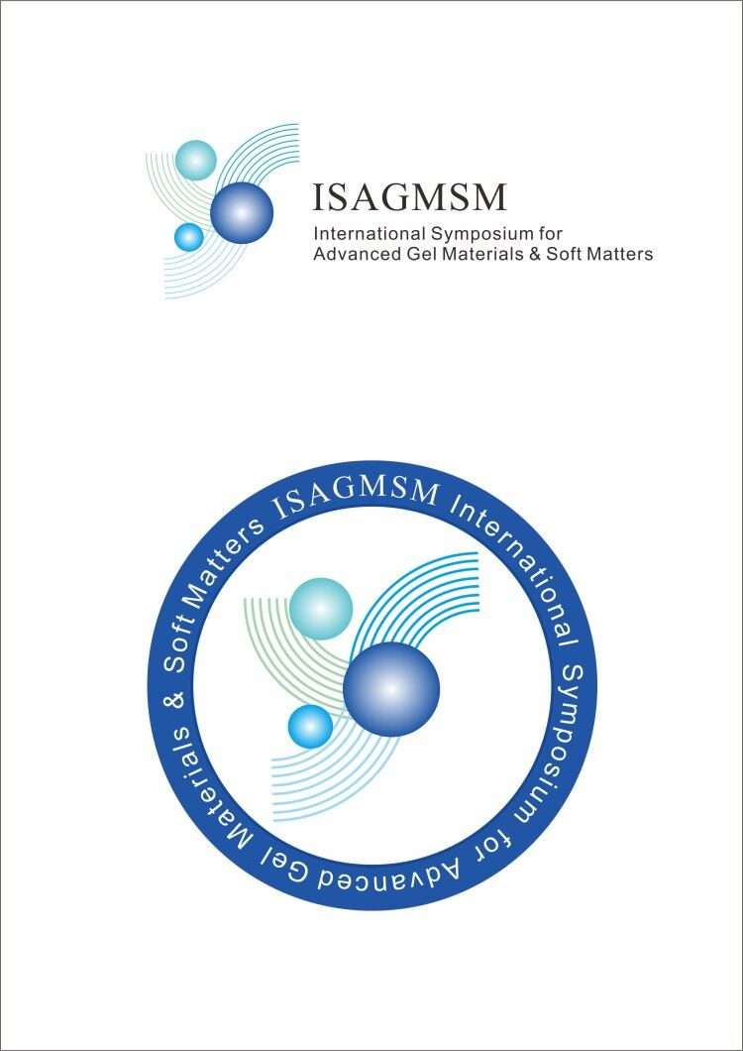

**The 3rd International Symposium for Advanced Gel Materials & Soft Matters** (**ISAGMSM)**

**Xi’an, China**

**Jun. 14-17, 2019**

 

 

As launched by Institute of Physical and Chemical Research of Japan (RIKEN), Hokkaido University, Institute of Chemistry China Academy of Sciences, Zhejiang University, Shaanxi University of Science and Technology, Xi’an Jiaotong University, Tianjin University of Technology, Zhuhai GuoJia New Material Co.Ltd, The 3rd International Symposium for Advanced Gel Materials & Soft Matters (ISAGMSM) will be held on Jun. 14-17, 2019.

The 1st ISAGMSM was successfully held at Beijing, China in October, 2016. The 2nd ISAGMSM was successfully held at Guiyang in August, 2017. It gathered over 100 experts in gel materials & soft matter to discuss the latest progress in these fields. The symposium also held a special section of polymer condensed state and conjugated polymer & ceremony of Renyuan QIAN’s centenary birthday.

The 3rd ISAGMSM will be held in Shaanxi University of Science & Technology (Xi’an) on June 14-17, 2019. Your active participation is highly welcome.

**1. Dates**

Conference period is June 14-17, 2019, Check-In date is June 14, 2019 (full day). Registration is open on Apr. 1, 2019, and the deadline of registration is May. 10, 2019.

**2. Conference Theme**

1. Hydrogel
2. Org-gel
3. Areogel and porous material
4. Hybrid gel material
5. Soft matter and smart materials

**3. Conference address and main traffic routes**

**Conference address：**Shaanxi University of Science and Technology(SUST)（Academic lecture hall, ground floor of SUST library）

** Xi’an airport to SUST：**About 40 minutes by taxi (about 100￥); or first 30 minutes to Xian north station (high-speed rail station) by airport bus (about 26￥), then 15 minutes by taxi to Shaanxi University of Science and Technology (about 16￥).

** Xi’an north station (high-speed rail station) to SUST：**About 15 minutes by taxi to Shaanxi University of Science and Technology (about 16￥).

** Xi’an railway station to SUST：**About 40 minutes by taxi (about 36￥); or 60 minutes by bus 719 or bus 517 (3￥)；or first 30 minutes to Beiyuan station by subway (3￥), then 10 minutes by taxi to Shaanxi University of Science and Technology (about 14￥).

**4. The main hotel for conference**

**Shaanxi Xianglong Grand Hotel**（☆☆☆☆）

Contract price: 348￥for grand standard rooms, 378￥for single rooms, and 688￥ for suite rooms, located at the southeastern corner of Shaanxi University of Science and Technology on Wude Road in Weiyang district of Xi’an city, Shaanxi province）

**5. Presentation Guidelines**

This call for abstracts is for proposals including oral and poster presentations. Oral presentation (15 min) enjoy a coordinate position with invited talk (30 min). The normal size of a poster is 120cm*90cm. The official language of the conference is English. Every attendee can only have one presentation.

**6. Import time points**

Submission of Abstract: Apr. 1st, 2019 ~ May. 20th, 2019

Online Registration: Apr. 1st, 2019 ~ May. 20th, 2019

Conference Check-In: Jun. 14th, 2019

**7. Sponsor & Organizer**

**Sponsored by:** Polymer Materials and Engineering Society of China, CMRS

**Organized by:** Shaanxi University of Science and Technology

**Co-Organized by:** Zhuhai GuoJia New Material Company, Ltd.; Institute of Chemistry, China Academy of Sciences; Xi’an Jiaotong University; Zhejiang University; Tianjin University of Technology

**8. Conference Board**

**Chairman:** Yoshihito Osada, Jian Ping Gong, Jian Zhong Ma **Executive Vice-Chairman:** Jian Xu, Yong Mei Chen

**Organizing Committee Members:** Li Chen, Jianhua Dong, Tai Sheng Gong, Xin Ping Li,

Jin Ma, Haibo Wang, ZiLiang Wu, Ning Zhao, Yongjun Zhang, Qiang Zheng

**Secretary-general:** Jian Hu, Tao Lin Sun, Zi Liang Wu, Hui Jie Zhang

**Vice Secretary-general:** Haibo Wang

**9. Registration & Contact Information**

**(1)** The registration fee is 2000￥, 1200￥for students with board and lodging excluded. The payment method and account are yet to be decided.

*Note: June is the busy season of Xi’an and the occupancy rate of hotel is high. Thus please determine your accommodation and inform the conference committee before May 20th, 2019.*

**(2)** Contact information of the conference committee：Please send us for registration or other information.

**Contact person:**

Jian Hu (Tel: +86-15888770823, Email: hujian@mail.xjtu.edu.cn)

Huijie Zhang (Tel: +86-15710443286, Email: 646346958@qq.com)

Yong Mei Chen (Tel: +86-13227788790, Email: [913898005@qq.com](mailto:913898005@qq.com))