Guideline for the online payments of ICAFPM 2017
- Register on the payment platform
  - Visit the website：http://epay.dhu.edu.cn/p/ and register first :
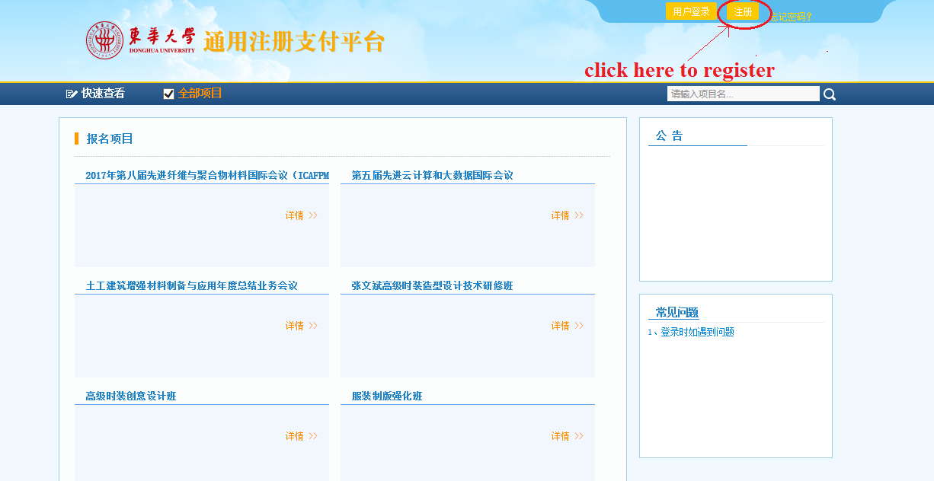
1.2 Input the corresponding information on the finishing page and click register.
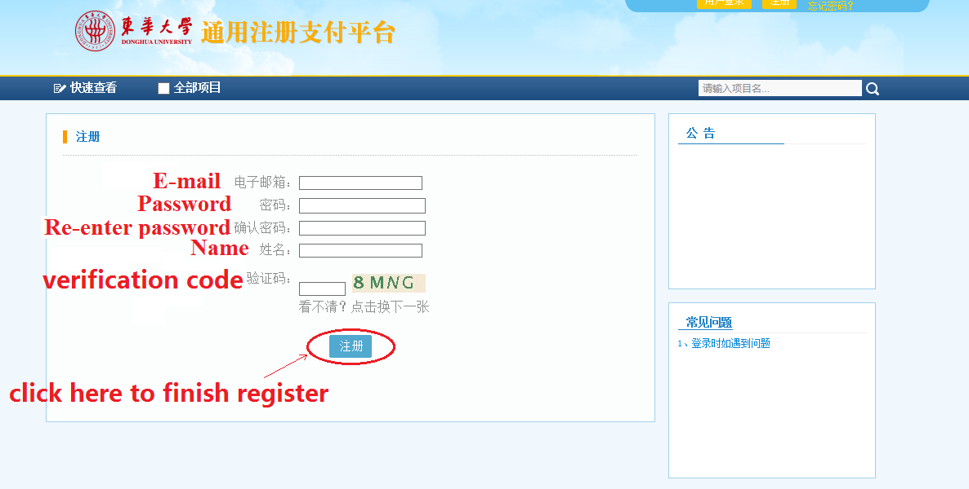
1.3. Log in with your register account by filling the floating dialogue
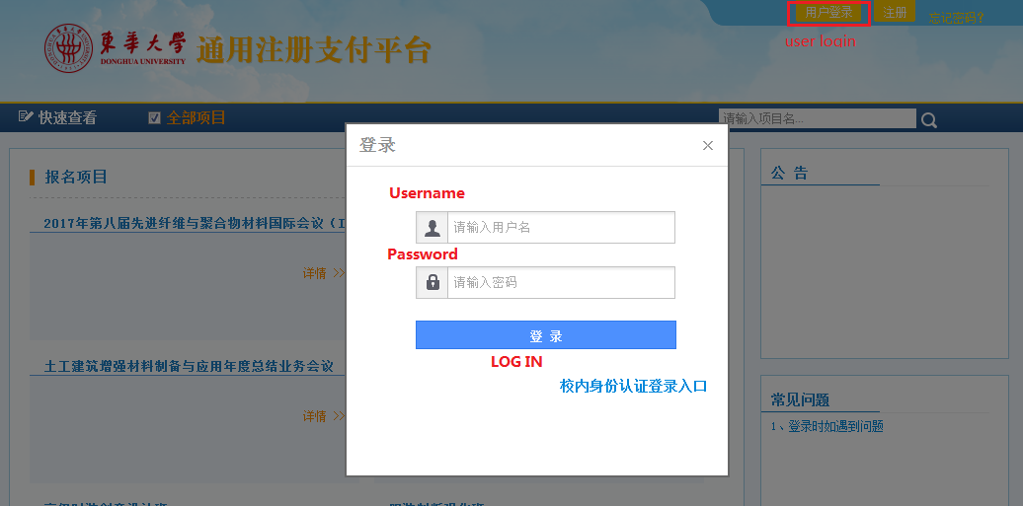

- Placing payment order of ICAFPM2017
2.1 Go back to the website: http://epay.dhu.edu.cn/p/, choose the payment link of ICAFPM2017
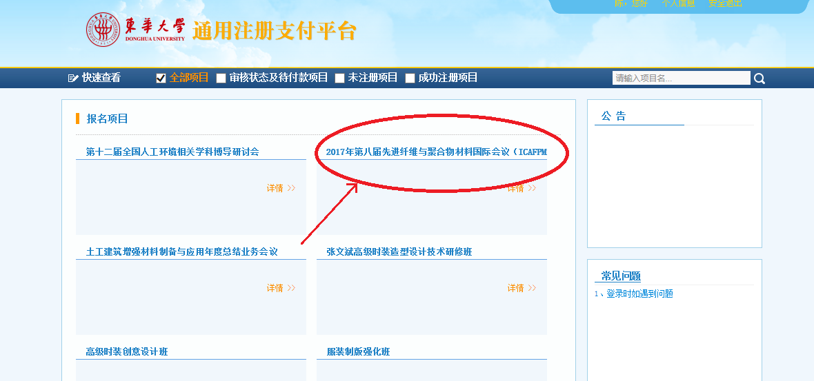
2.2 Then, click the blue button and transfer to the payment page
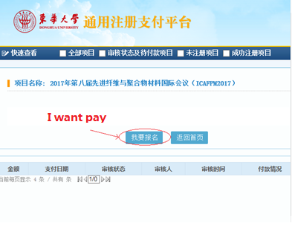
2.3 Filling the correct and detail information of participant, then click the save button
People from Taiwan and Hongkong please choosing the standardized payment of the first two line
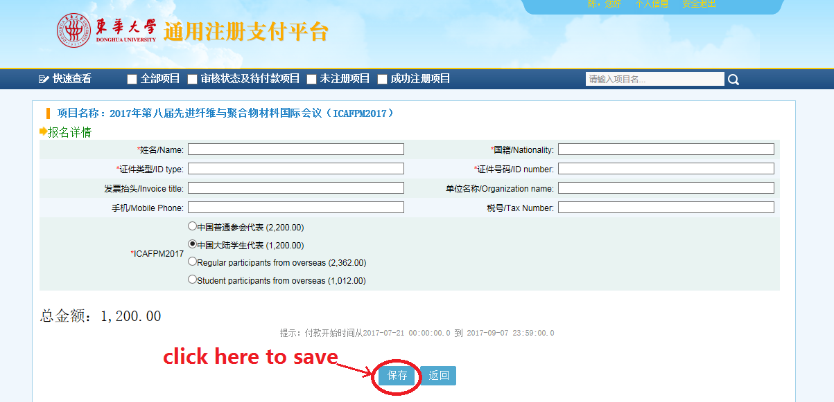
2.4 Final proof of your information and your order, click “Pay ” and go to the payment page.
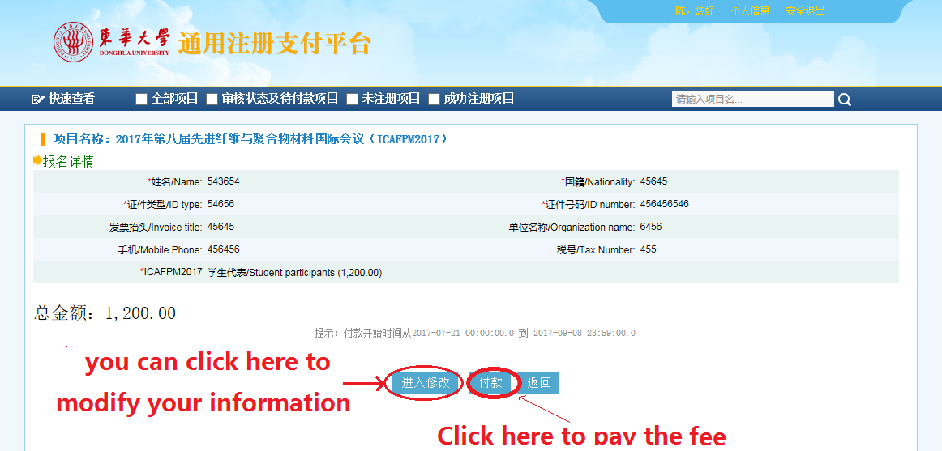

- Finishing the online payments
3.1 click the botton on the upper part of page to change the page into English version. And reconfirm your payments and choose the channel of the payment
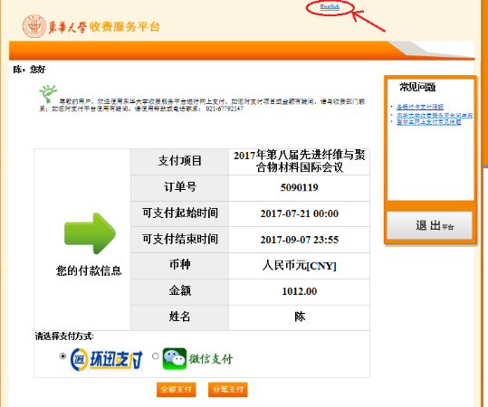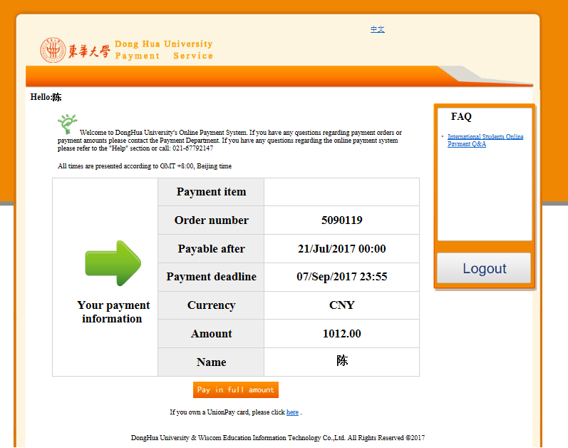
If you have Chinese bank account, then we suggest you choose and click “PAY ALL”.

3.2 Additional fee may be charged in paying with international “visa” or “master” card. If you accept this, please click the “OK” in appearing alerts.
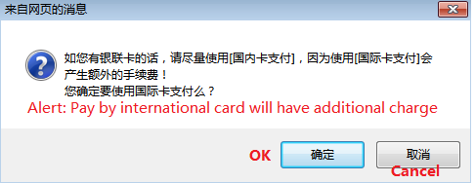

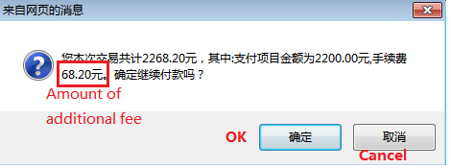

3.3 Pay the registration fee and the involving additional fee as your normal online shopping.
